Project Title
Iphone 8

Project Graphic
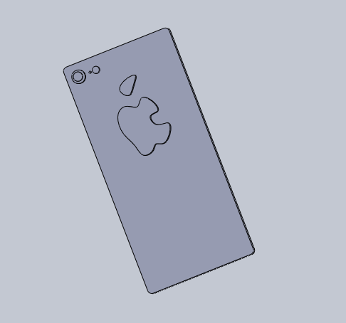

Group Name (if applicable)
Name(s) of Designer(s)
Cedarcrest High School
Date
4/20/19
- Introduction (2 points)
  - Introduction paragraph(s) gives an overview of the project. Tell what the project is in general and specific terms. The project is an iPhone 8 its one of the latest phones on the market that apple has produced.

- Target Market (2 points)
  - Give a description of who would use the product and / or a customer list. (It could be a design for one specific user.) People who use their phone constantly and people who keep their work things on their phone because it is the easiest thing in the world to get your information back.

- Success in Creating Product (16 points)
  - Answer the question: How successful were you in creating the product?
  - I thought making this project was fairly easy because it was small and simple.
  - Give lessons learned (at least 2). Such as what you would do again (2). What you would not do again (2) I learned how to use spline to make my apple logo.
  - Give specific and appropriate supporting details (12). Use as many paragraphs as needed to fully explain. (You may also embed screen shots.)

- Product Sketches and Ideas (8 points)
  - Along with the sketches, you need to talk about the ideas that led to the sketches. The sketches themselves are worth 2 points of the 8 for the section.
  - Describe how you decided on the project (2), what requirements you decided on (2), and how you met those requirements with your design (2). I decided to make an iphone because I use my phone constantly and it was the first thing that popped in my head, I didn’t have many requirements because it was easy to make.

- Product Drawings (8 points)
  - You need product drawings (6 points). Along with the drawings, give some explanation of what the drawings are (2).

- Product Renderings and/or Physical Models (4 points)
  - Put together enough renderings to show off your product. (3) These renderings (and /or pictures of physical models) must show case the product in the best light for customers or potential customers to want to obtain the product. Also give a short explanation of how you would go about appealing to customers (1).
Appendix/Notes

You can put other notes or thoughts into the Appendix/Notes section. These are thoughts or notes that do not fit into the other categories but add to the understanding of the product. The Appendix/Notes section may be deleted if not used.

By the way, edit the header (put the title of your project) and footer (replace “Name” with your name so that it appears on each page).

